MYSQL

Download and Installation

1. Download “mysql-installer-community-5.6.28.0.msi” from the below url

<https://dev.mysql.com/downloads/file/?id=460602>

1. Double click the “mysql-installer-community-5.6.28.0.msi”, which will start the installation process

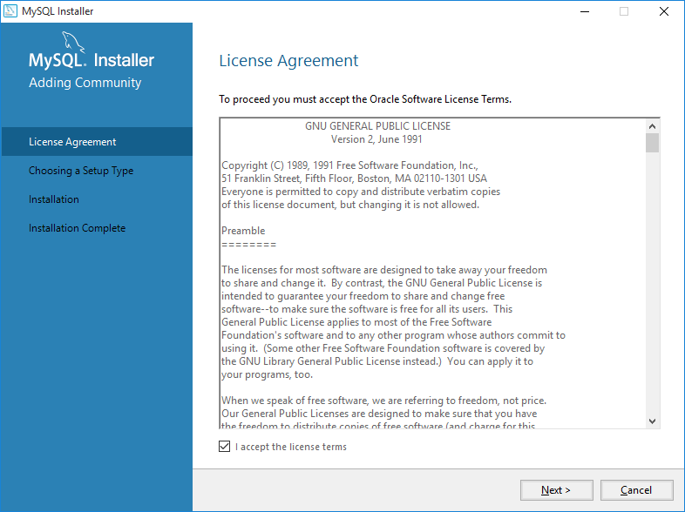

1. Select “Default” option and click next.

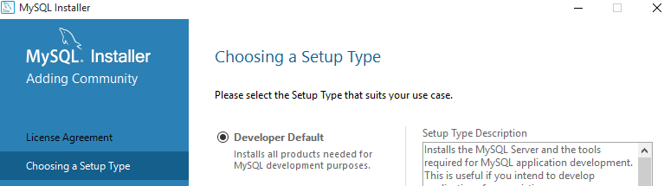

1. Click “Next”

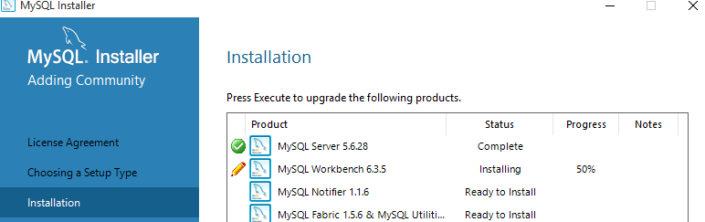

1. Click “Next”

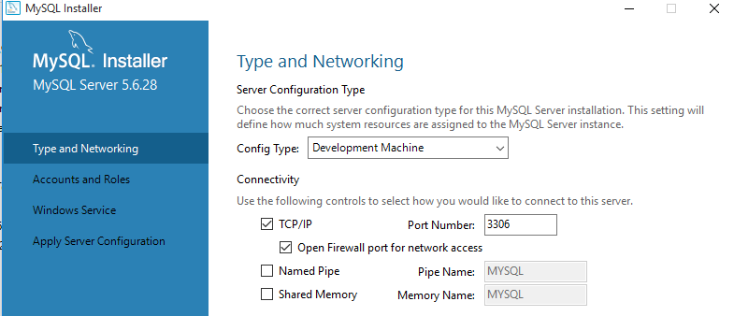

1. Enter password for “root” and also create a new user and password

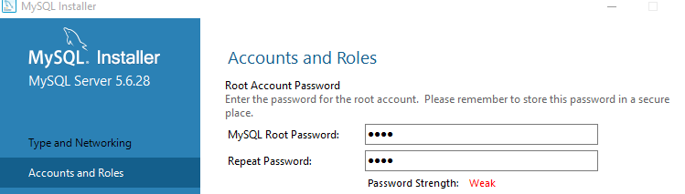

1. If you want to create “user Accounts”, Click “Add user” and enter user id and password

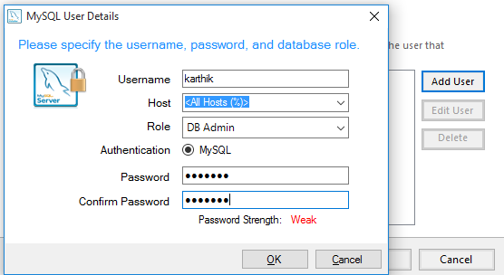

1. Click “Execute”
2. Click “Finish”